EXHIBIT
Audience Access & Sensory Guide
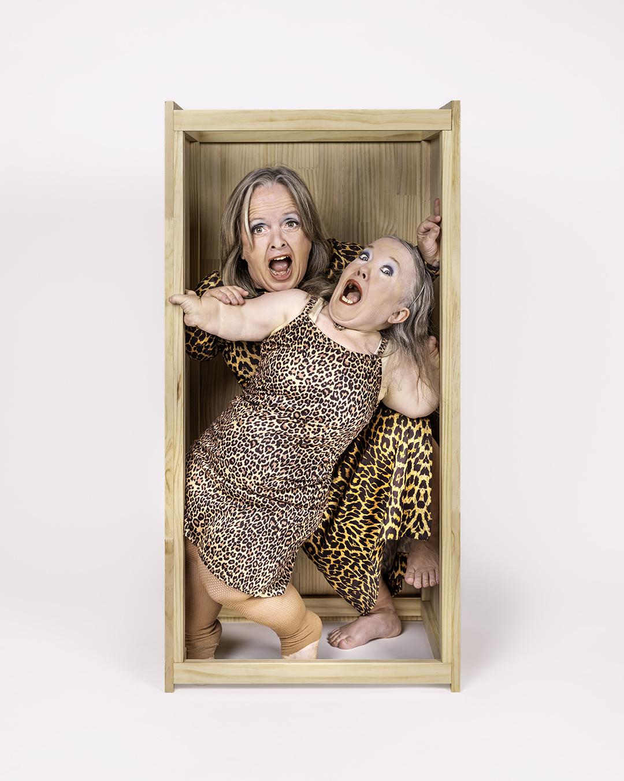
Two short-statured women are squeezed inside a narrow, wooden box. They are wearing matching leopard-print outfits. They pull exaggerated, open-mouthed expressions as they twist and lean around each other in the confined space.

About this Guide
This guide is designed to help audiences make informed choices about attending Exhibit. It outlines themes, sensory elements and performance styles that may be encountered during the performance.
Exhibit is a contemporary physical theatre work that blends autobiographical storytelling, dance, circus, movement, satire and visual theatre. It explores disability, identity, ageing, visibility and belonging through humour, personal reflection and symbolic imagery.
Not every audience member will experience the work in the same way. This guide is intended to support access and choice without diminishing the experience of discovery.
Running Time: Approximately 50 minutes (no interval)

Performance Style
Throughout the performance, audiences will experience a variety of theatrical forms, including:
- spoken monologues and dialogue
- non-verbal physical theatre
- contemporary dance
- visual and object theatre
- satire and comedy
- autobiographical storytelling
- live singing (a cappella)
- original music and soundscape
Scenes alternate between spoken and non-verbal storytelling.

Content Overview
Exhibit explores themes including:
- disability identity and lived experience
- ableism and discrimination
- visibility, being observed and social judgement
- self-esteem and internalised beliefs
- body image and ageing
- beauty standards
- identity and belonging
- artistic identity and creative practice
- rejection and competition
- grief and bereavement
- mortality and legacy
- resilience, connection and self-determination
The performance balances humour with emotionally reflective material.

Content Advisories
The performance contains:
- discussions of disability and lived experience
- references to discrimination and prejudice
- strong emotional themes relating to identity and self-worth
- occasional coarse language
- references to sexuality and desirability
- brief partial nudity presented comedically
- metaphorical descriptions of violence (no enacted violence)
- themes of grief, death and bereavement
- a concluding dance responding to the performer's experience of profound loss.
The production DOES NOT contain:
- graphic violence
- graphic sexual content
- depictions of self-harm
- realistic gore
The mention of these elements in the script is presented comedically.

Sensory Information
The performance includes:
Sound
- original music and ambient sound
- live voices and spoken text
- recorded voiceover
- live a cappella singing
- occasional loud or sudden sound
- repeated loud buzzer sounds during one scene
- occasional sudden vocal interruptions
Lighting
The production uses theatrical lighting throughout.
The performance currently includes:
- changing lighting states
- spotlights
- general stage lighting
- one brief blackout
The production DOES NOT include:
- strobe lighting
- flashing effects
- haze
- pyrotechnics

Movement
The performance contains frequent physical movement including:
- contemporary dance
- object manipulation
- stylised physical theatre
- choreographed movement sequences
Large scenic objects (boxes and latch hooks) are moved throughout the performance.

Scenic Elements
The production features:
- wooden boxes that are continually rearranged
- latch hook frames
- wearable beanbags
These objects become different environments and visual images throughout the performance.

Audience Interaction
There is no audience participation.
The performers occasionally address the audience directly; however, audience members are never asked to participate or come on stage.

Emotional Journey
The emotional tone shifts throughout the performance.
Audiences may experience:
- humour
- satire
- absurdity
- vulnerability
- joy
- frustration
- anger
- tenderness
- grief
- hope
Some scenes contain deeply personal autobiographical material.

Scene-Specific Notes
Some scenes may be particularly relevant for audiences with lived experience of:
- disability discrimination
- body image concerns
- ageing
- artistic rejection
- grief and bereavement
- the death of a child.
Accessibility
The performance includes both spoken and non-verbal scenes.
Storytelling is communicated through a combination of:
- speech
- movement
- choreography
- visual imagery
- music
- theatrical metaphor
There is no audience participation.

For Front-of-House Staff
Audience members may wish to know that:
- the production alternates between comedy and emotionally intense material
- loud buzzer sounds occur during Scene 7: The Audition Battle
- there is one brief blackout
- the concluding section explores grief through dance rather than literal depiction
- the final duet builds gradually in intensity before ending abruptly
- the performance concludes immediately following the final movement sequence

Overall Intensity
Category | Level
Emotional themes | High
Sensory intensity | Moderate
Loud sounds | Moderate (primarily Scene 7)
Physical movement | High
Strong language | Low–Moderate
Violence | Low (metaphorical only)
Sexual content | Low
Audience participation | None

Venue Access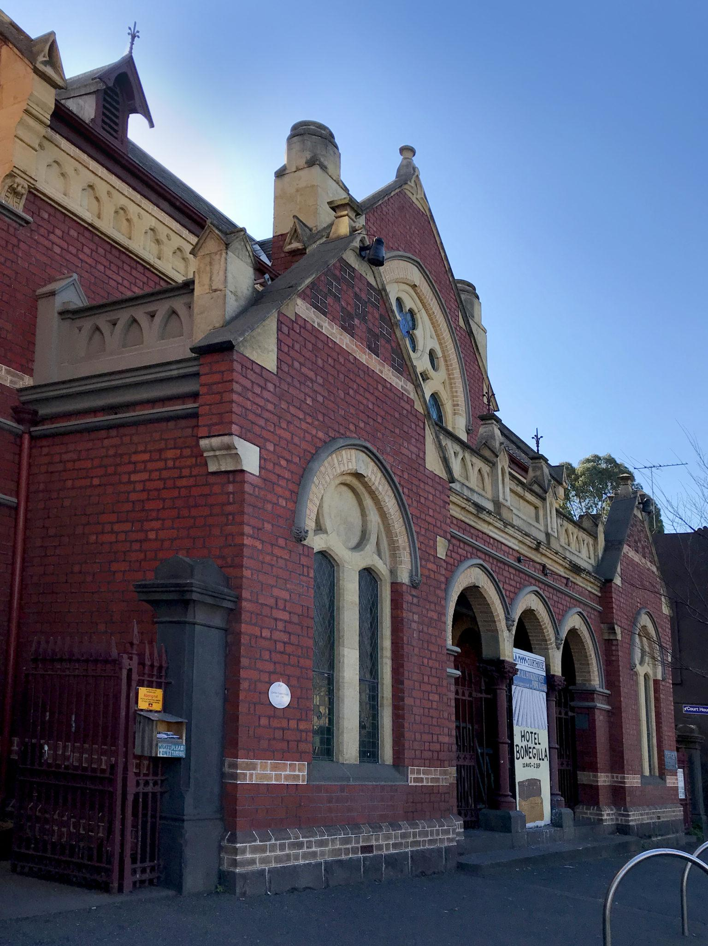
Image description: The red-brick La Mama Courthouse, with pale stone trim, arched windows and a recessed entrance, viewed from the footpath.
La Mama Courthouse
349 Drummond Street
Carlton VIC 3053
Wheelchair/Scooter Access
La Mama Courthouse is wheelchair accessible for audiences and artists.
The theatre doorway is approximately 86 cm wide. If your wheelchair or mobility device is wider than this, please contact La Mama before attending so they can discuss how best to accommodate you.
La Mama welcomes Companion Card holders and assistance animals. Assistance animals are welcome inside the venue, and water bowls are available.

Getting There
Car
La Mama Courthouse is in Carlton, close to Lygon Street and Melbourne's CBD.
There is street parking in the surrounding area, including accessible parking spaces. There is also a 10-minute loading zone directly outside the Courthouse.
If you require accessible parking or assistance getting into the venue, we recommend contacting La Mama before your visit.
Public Transport
La Mama Courthouse is accessible by tram, bus and train.

By Tram
The closest tram stop is Stop 112 – Lygon Street / Elgin Street, served by Routes 1 and 6. From there, it is approximately a 4-minute walk to La Mama Courthouse along Elgin Street and Drummond Street.
Accessible tram travel:
Stop 112 has level access for boarding and alighting from low-floor trams.
Please check that your tram is low-floor before travelling. Not every tram operating on Routes 1 and 6 is low-floor. The wheelchair symbol on PTV's tramTRACKER indicates when an accessible tram is approaching.
An alternative is Stop 1 – Melbourne University / Swanston Street, which also has accessible boarding. From there, it is approximately a 7-minute walk to La Mama Courthouse.
If you require step-free travel, we recommend checking your complete journey using PTV's Journey Planner before travelling, as accessibility can depend on both the tram and the individual stop.

By Bus
Routes 200 and 207 stop at Lygon Street / Elgin Street, approximately a 2-minute walk from La Mama Courthouse.

By Train
Melbourne Central Station is the closest city train station. From Melbourne Central, you can connect with a tram or bus to Carlton.

Accessible Travel
If you use a wheelchair or mobility aid, we recommend checking your complete journey before travelling to ensure that each part of the journey provides step-free access.
For current information about accessible services, low-floor trams and journey planning, visit PTV.
Entering the Theatre
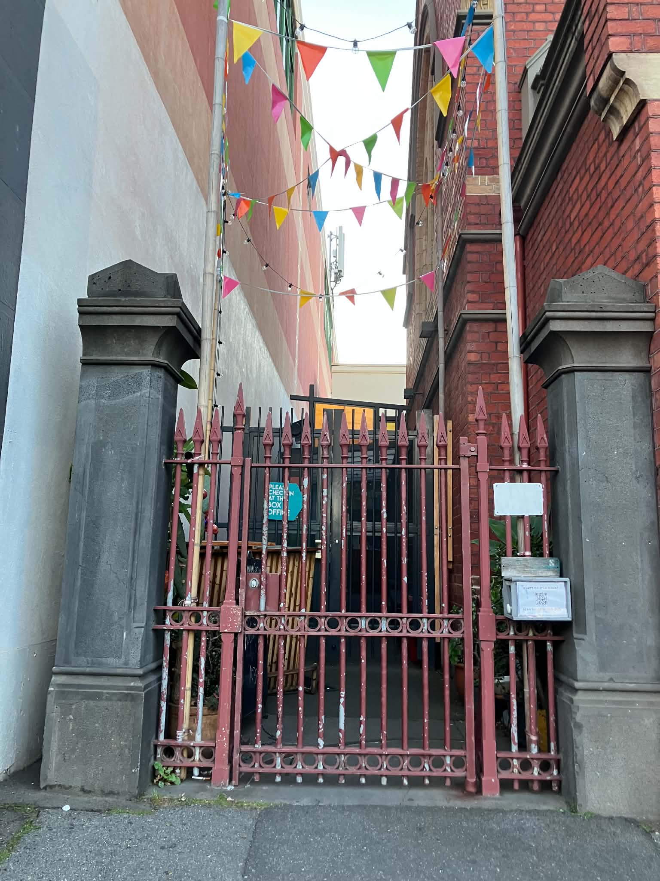
Image description: The narrow main entrance between a pale wall and the Courthouse's red-brick wall. A red metal gate stands between two grey stone posts, with colourful bunting overhead. These will be open when you arrive.
The Courthouse is an intimate theatre.
The theatre door is approximately 86 cm wide.
Please allow yourself enough time to arrive, enter the building and get comfortable before the performance begins.
La Mama has a lock-out policy: because of the intimate nature of the space, latecomers generally cannot be admitted once the performance has started.
The bar opens one hour before performances, and La Mama provides free tea and coffee.
Seating
La Mama Courthouse has theatre seating.
The standard theatre seat is approximately:
- 490 mm wide
- 530 mm deep
- 460 mm high
If you require wheelchair seating or have specific seating requirements, please indicate this when booking or contact La Mama directly.
Wheelchair bookings are available.

Toilets
La Mama's venue information states that the Courthouse has two unisex toilets, including one wheelchair-accessible toilet.
There is also a bathroom with a toilet and shower for staff, cast and crew.

Images
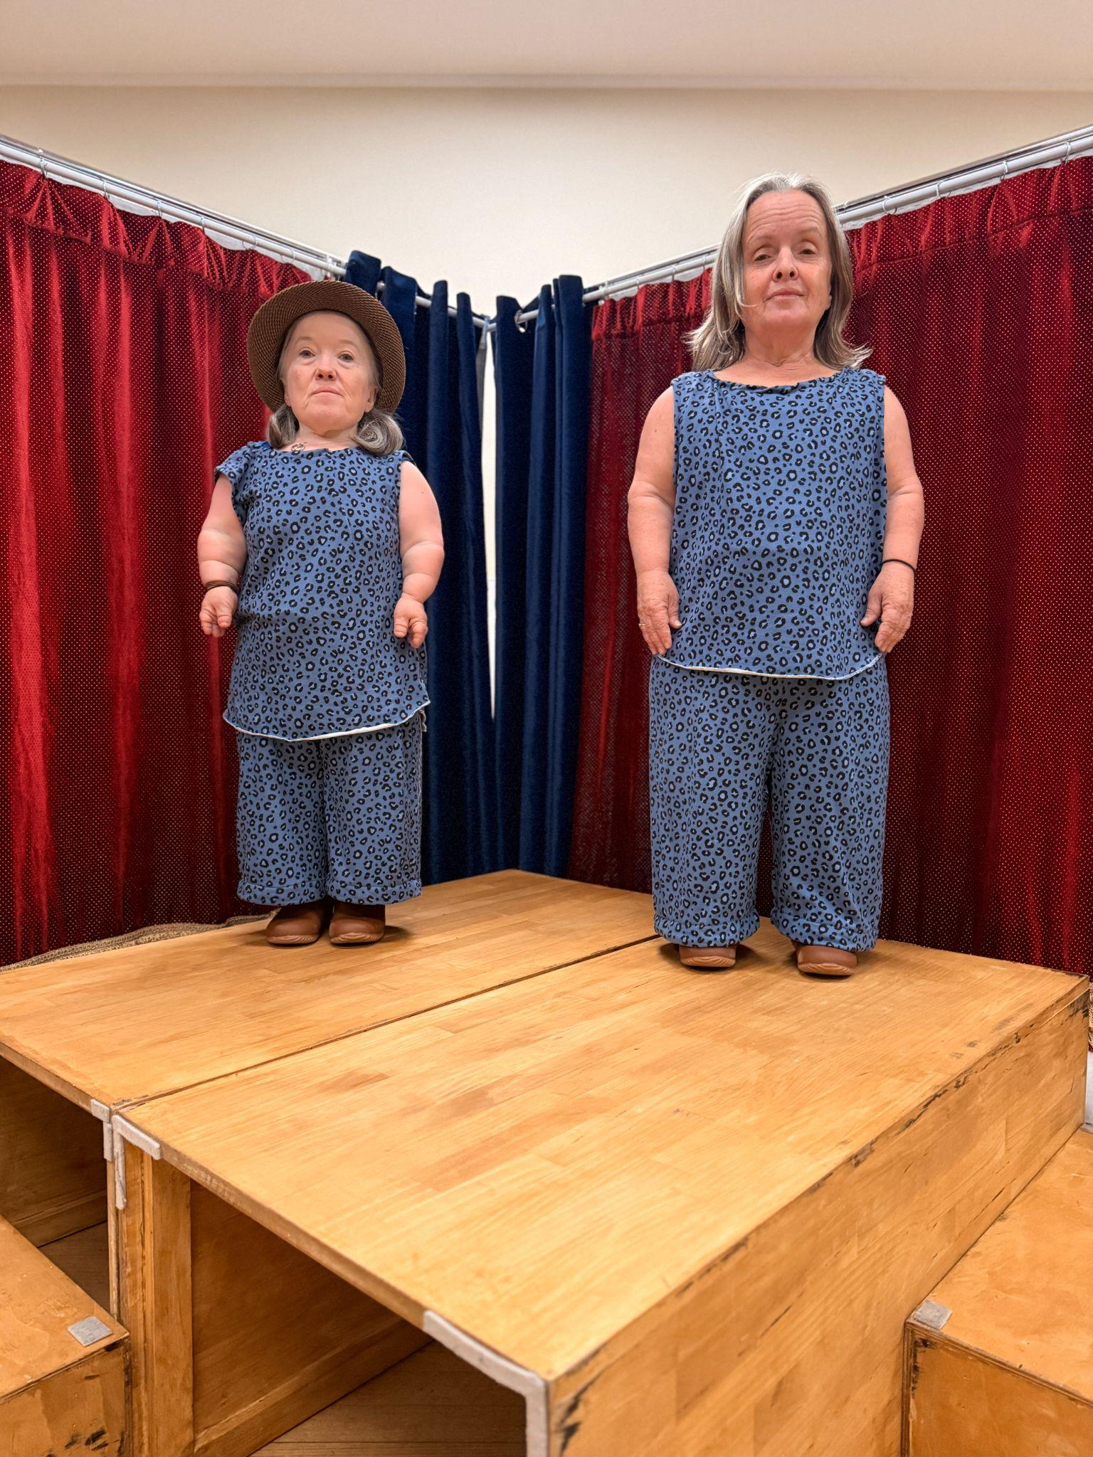
Image description: Emma J. Hawkins stands on the left in a brown hat, beside Leisa Prowd. Both wear matching blue leopard-print tops and trousers on a raised wooden platform, with red and navy curtains behind them.
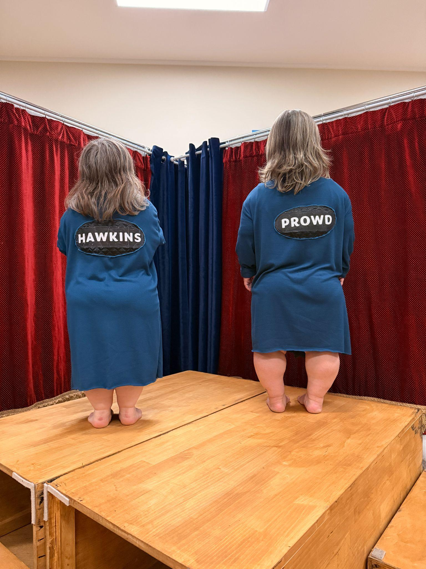
Image description: Emma J. Hawkins and Leisa Prowd stand barefoot with their backs to the camera on a wooden platform. The backs of their teal costumes read HAWKINS and PROWD, respectively.
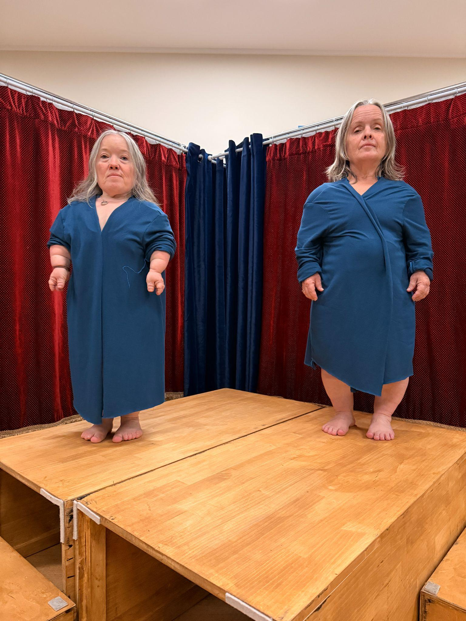
Image description: Emma J. Hawkins stands on the left and Leisa Prowd on the right, barefoot in loose teal costumes on a wooden platform framed by red and navy curtains.
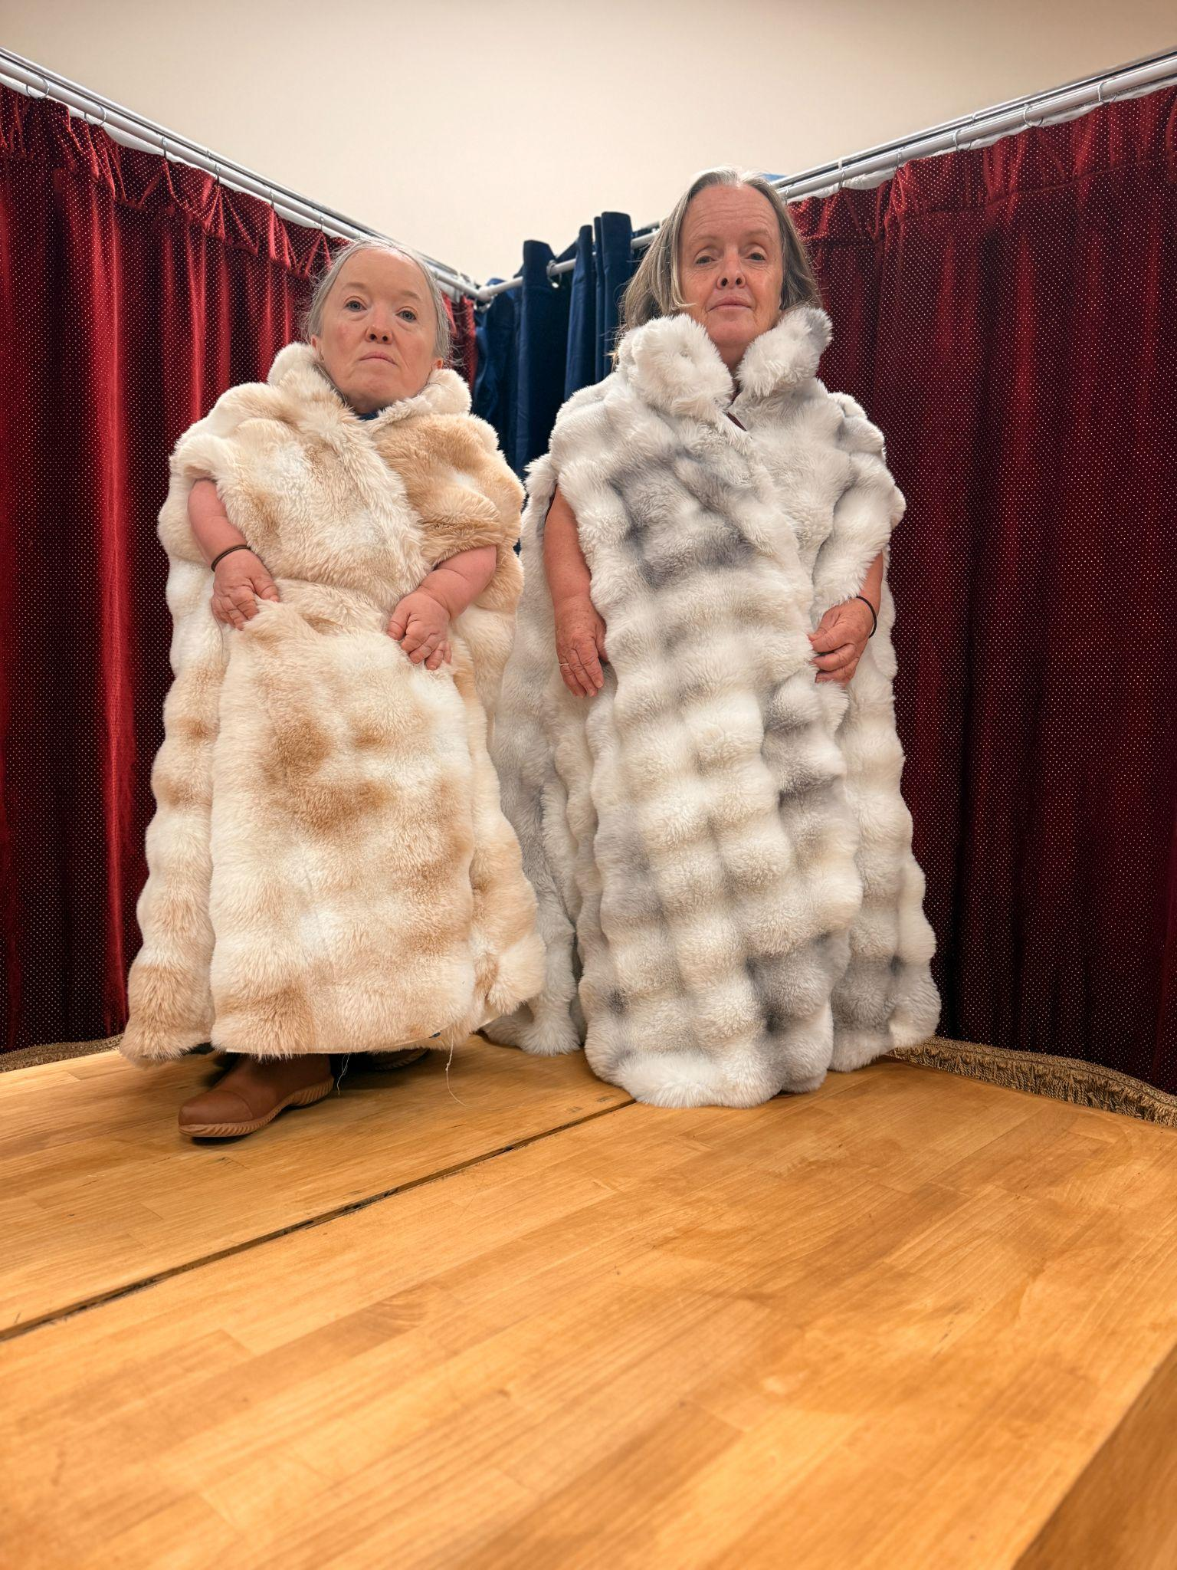
Image description: Two performers stand side by side on a wooden platform, wearing oversized cream and grey textured faux fur wraps with high collars, in front of red curtains.

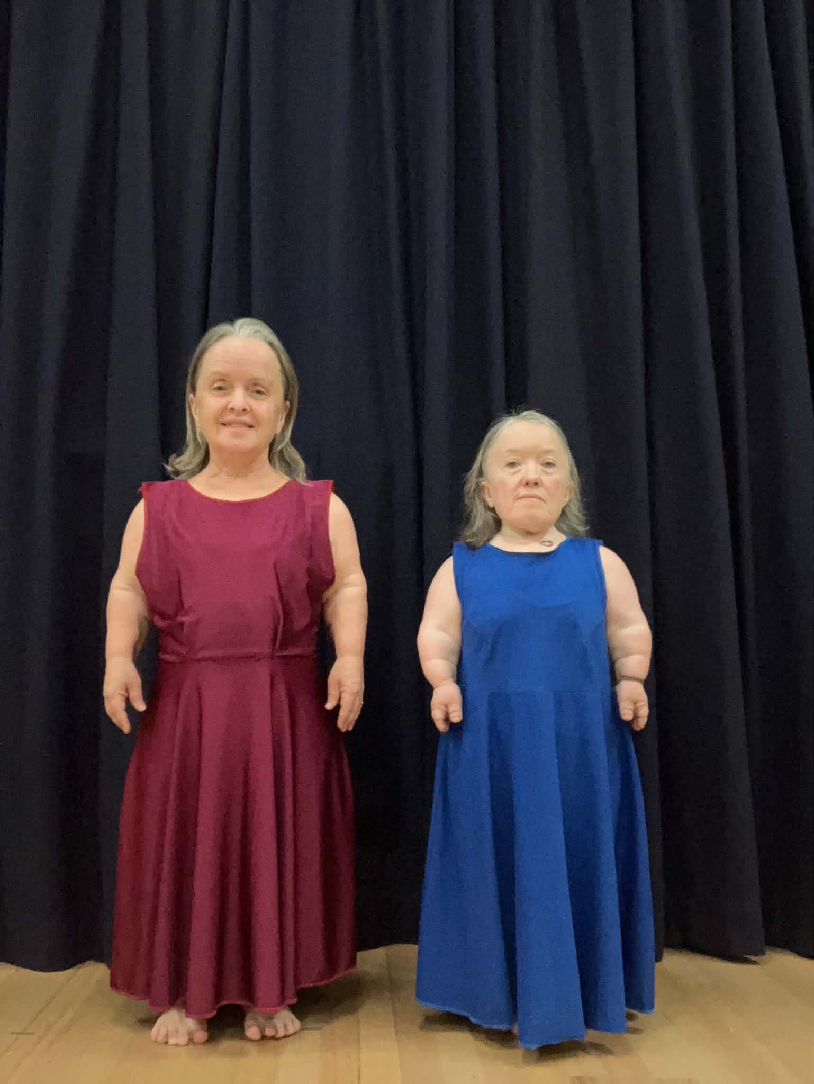
Image description: Leisa and Emma J stand barefoot before black curtains. Leisa is on the left and she wears a burgundy, ankle-length dress; Emma on the right, wears a blue, ankle length dress.
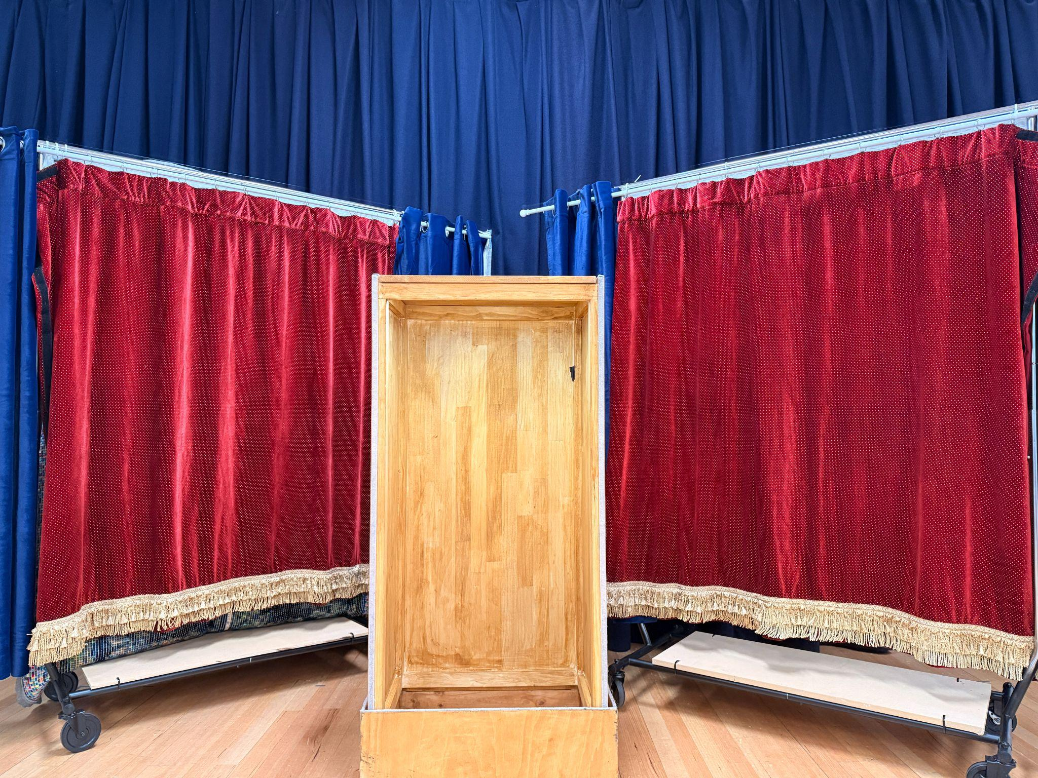
Image description: A tall, open wooden box stands upright at centre stage between red curtains edged with gold fringe and blue curtains behind.
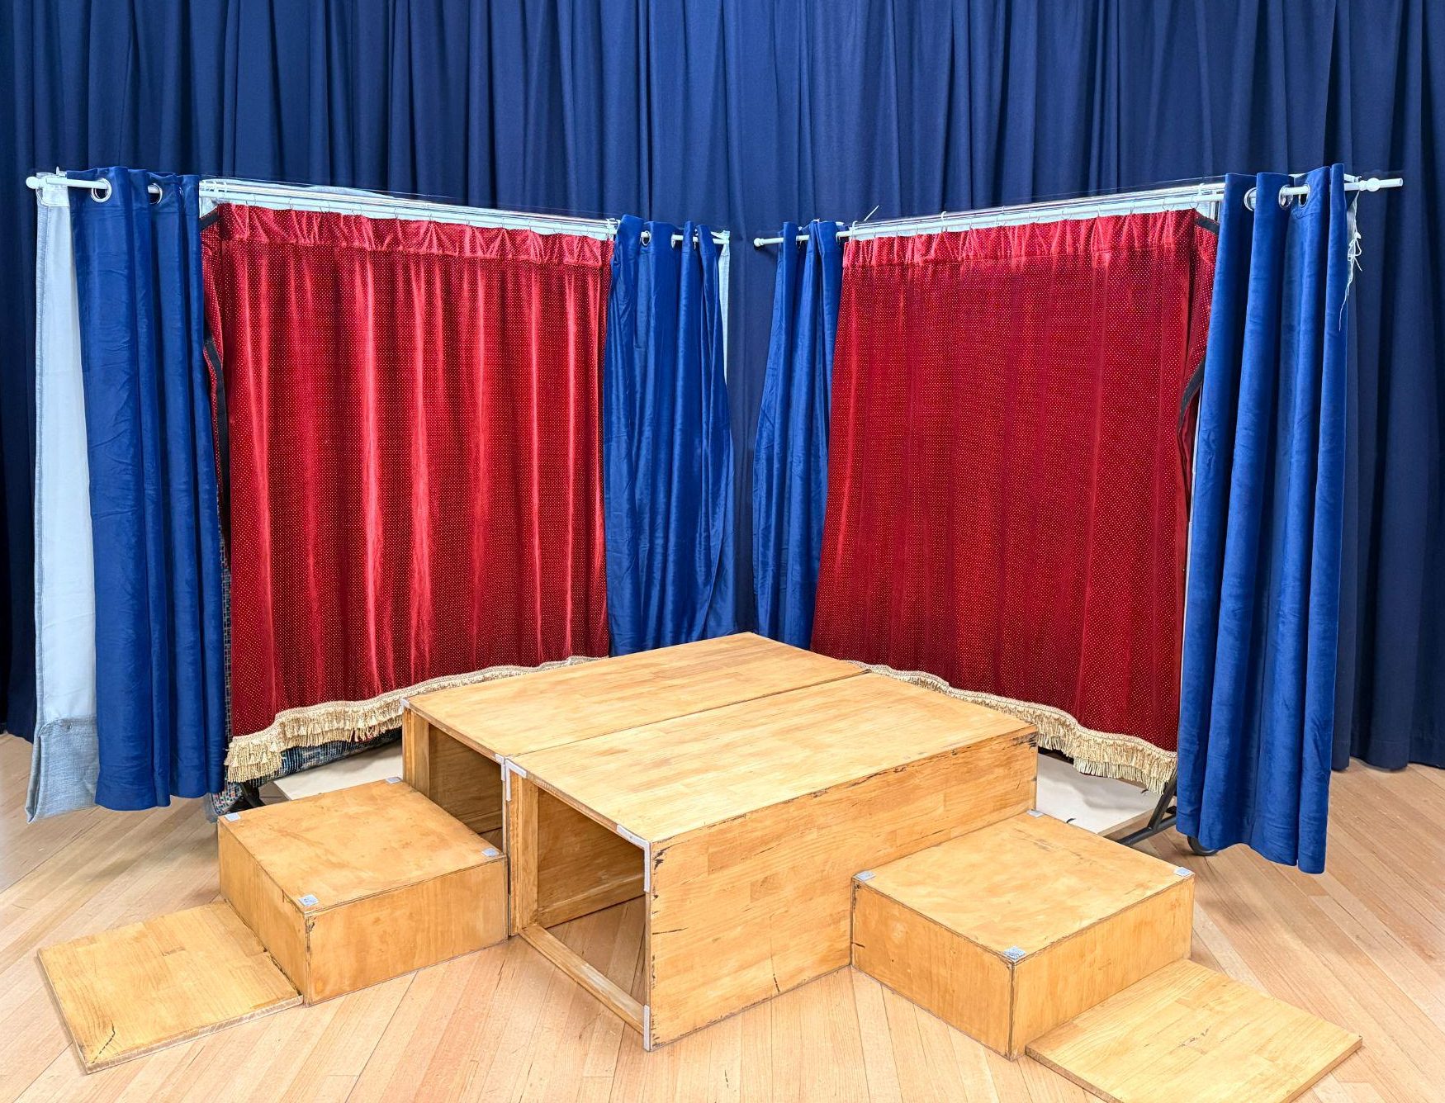
Image description: A large wooden box lies horizontally at centre stage, with smaller boxes and flat wooden panels on either side. This box configuration is known as “The Boxing Ring”.
Red and blue curtains surround the set.
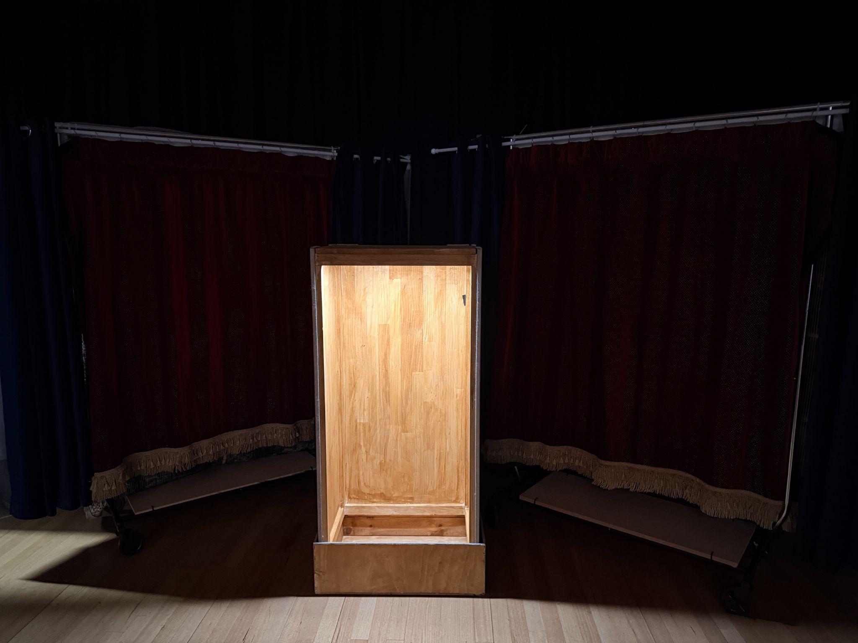
Image description: A single upright wooden box is lit from within on a dark stage, between barely visible red curtains. Leisa and Emma J stand in these boxes and perform various poses.

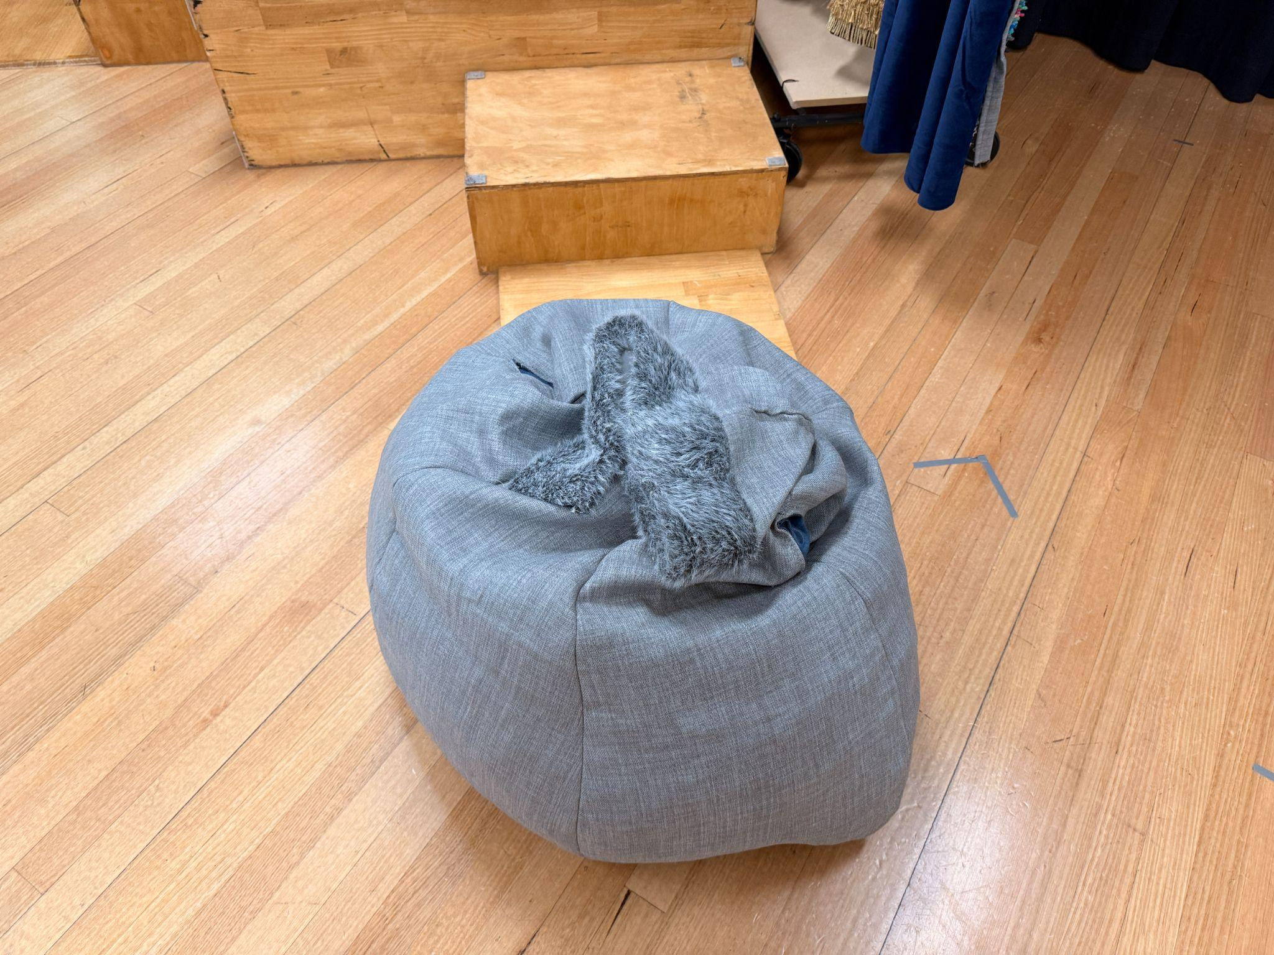
Image description: A soft, round grey beanbag with a fuzzy grey fabric piece gathered at its centre sits on a pale wooden floor; wooden set boxes are behind it.
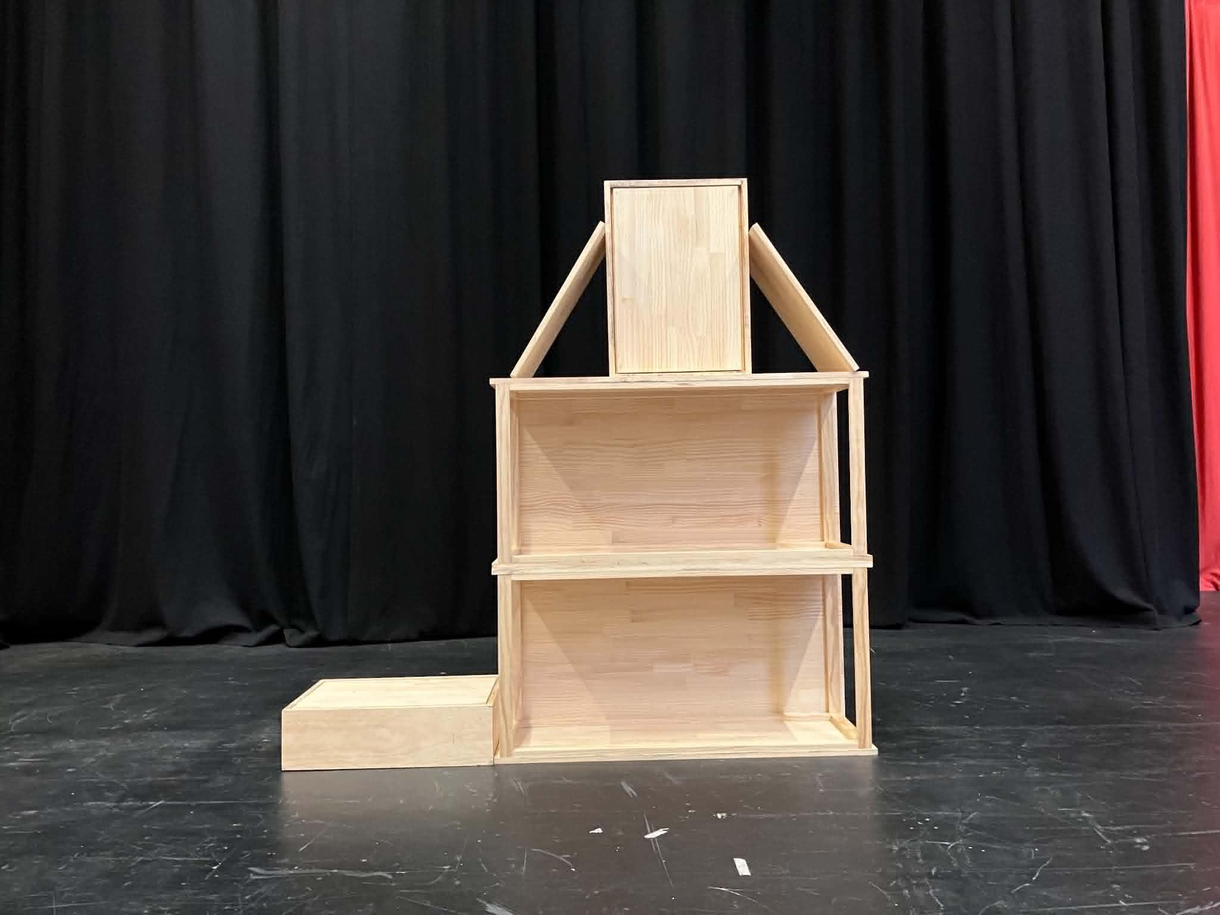
Image description: A stack of light wooden boxes is arranged in front of black curtains. The boxes are stacked to resemble the shape of a house, with two large open boxes, a small box at the top, and two angled boxes forming a roof. A shallow rectangular box sits on the floor to the left like a step. The boxes are simple, sturdy, and designed to be moved and rearranged.

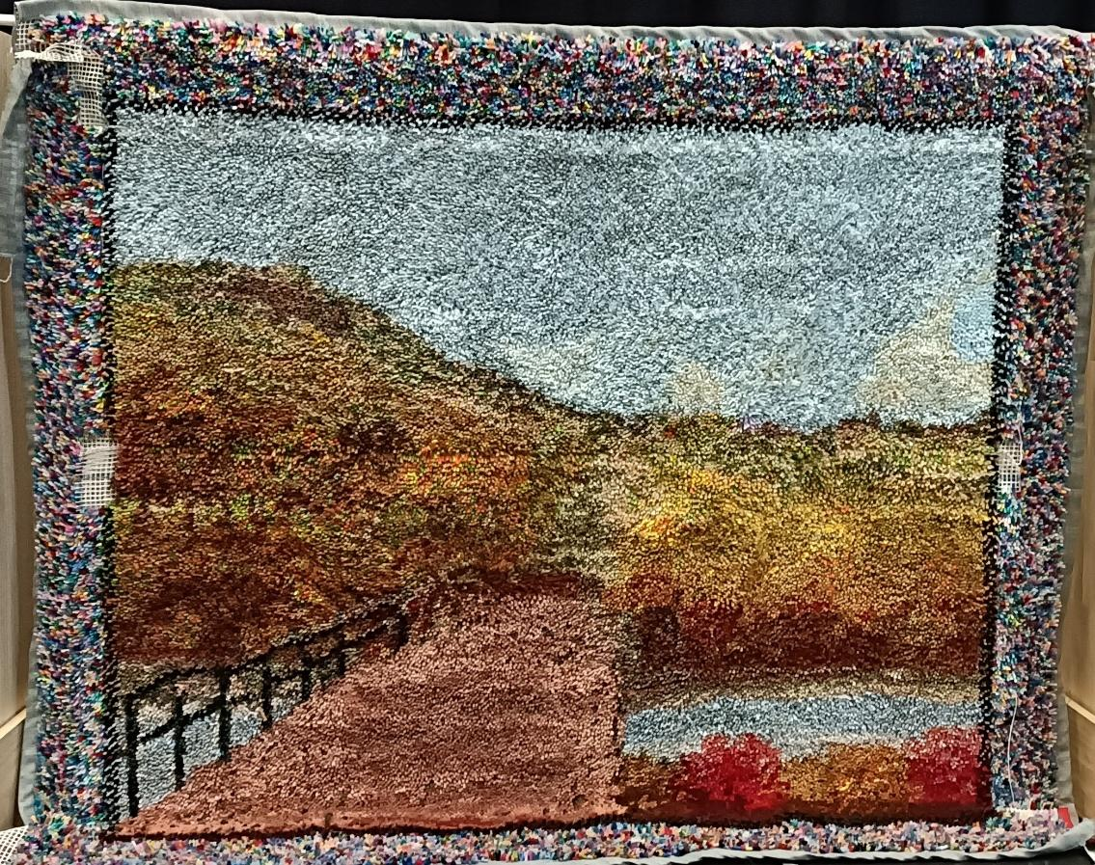
Image description: A large handmade latch-hook textile artwork depicting a landscape, with a winding path leading across a bridge, a hillside on the left, open fields, a pond, and a wide pale blue sky. The artwork is bordered by a thick multicoloured frame of yarn.

