Access Guide
How to Eat Rabbit by Jamila Main, presented at the La Mama Hope Punk Climate Festival 2026

Introduction
This is the access guide for How to Eat Rabbit, a play by Jamila Main which is being performed at La Mama Courthouse from 8 – 11 September.

In this document you can expect to find:
Event details
Cast & Crew
Content warnings
Ticketing
Information about the venue of the show
How to get there
Arriving at La Mama
Venue Accessibility
How you will be seated
Lock out policy
Other things around the venue
Information about the show
Depiction of Disability and Chronic Illness
Discussion of hunting, preparing and eating animals
References to climate change, apocalypse, fascism, and social collapse
Sequences depicting severe, undiagnosed pain and distress
Sequence depicting a medical emergency
Alcohol
Vomiting: Emetophobia Warning
Fake Blood
References to Death and Dying
References to Menstruation Using Nongendered Language
References to Pregnancy and Children
Infrequent Coarse Language
Information about the performers and characters
Visual Descriptions of the performers
Pictures and info about the space the show is performed in
Support resources

We hope this is a useful resource for you and that you enjoy the show! :)

About this guide
This guide was prepared by Ryan Hamilton (he/they) who is the marketing and access coordinator for How to Eat Rabbit.

To provide feedback and ask any further questions, They are the best person to contact about the show if you have feedback or further questions about this document.

This is what they look like (except without the pink hair at the moment). The photo is of a person with a moustache and light beard in front of a green background full of foliage. They are looking at the camera a little like the Mona Lisa, and have a big silver earring as well as a septum piercing.

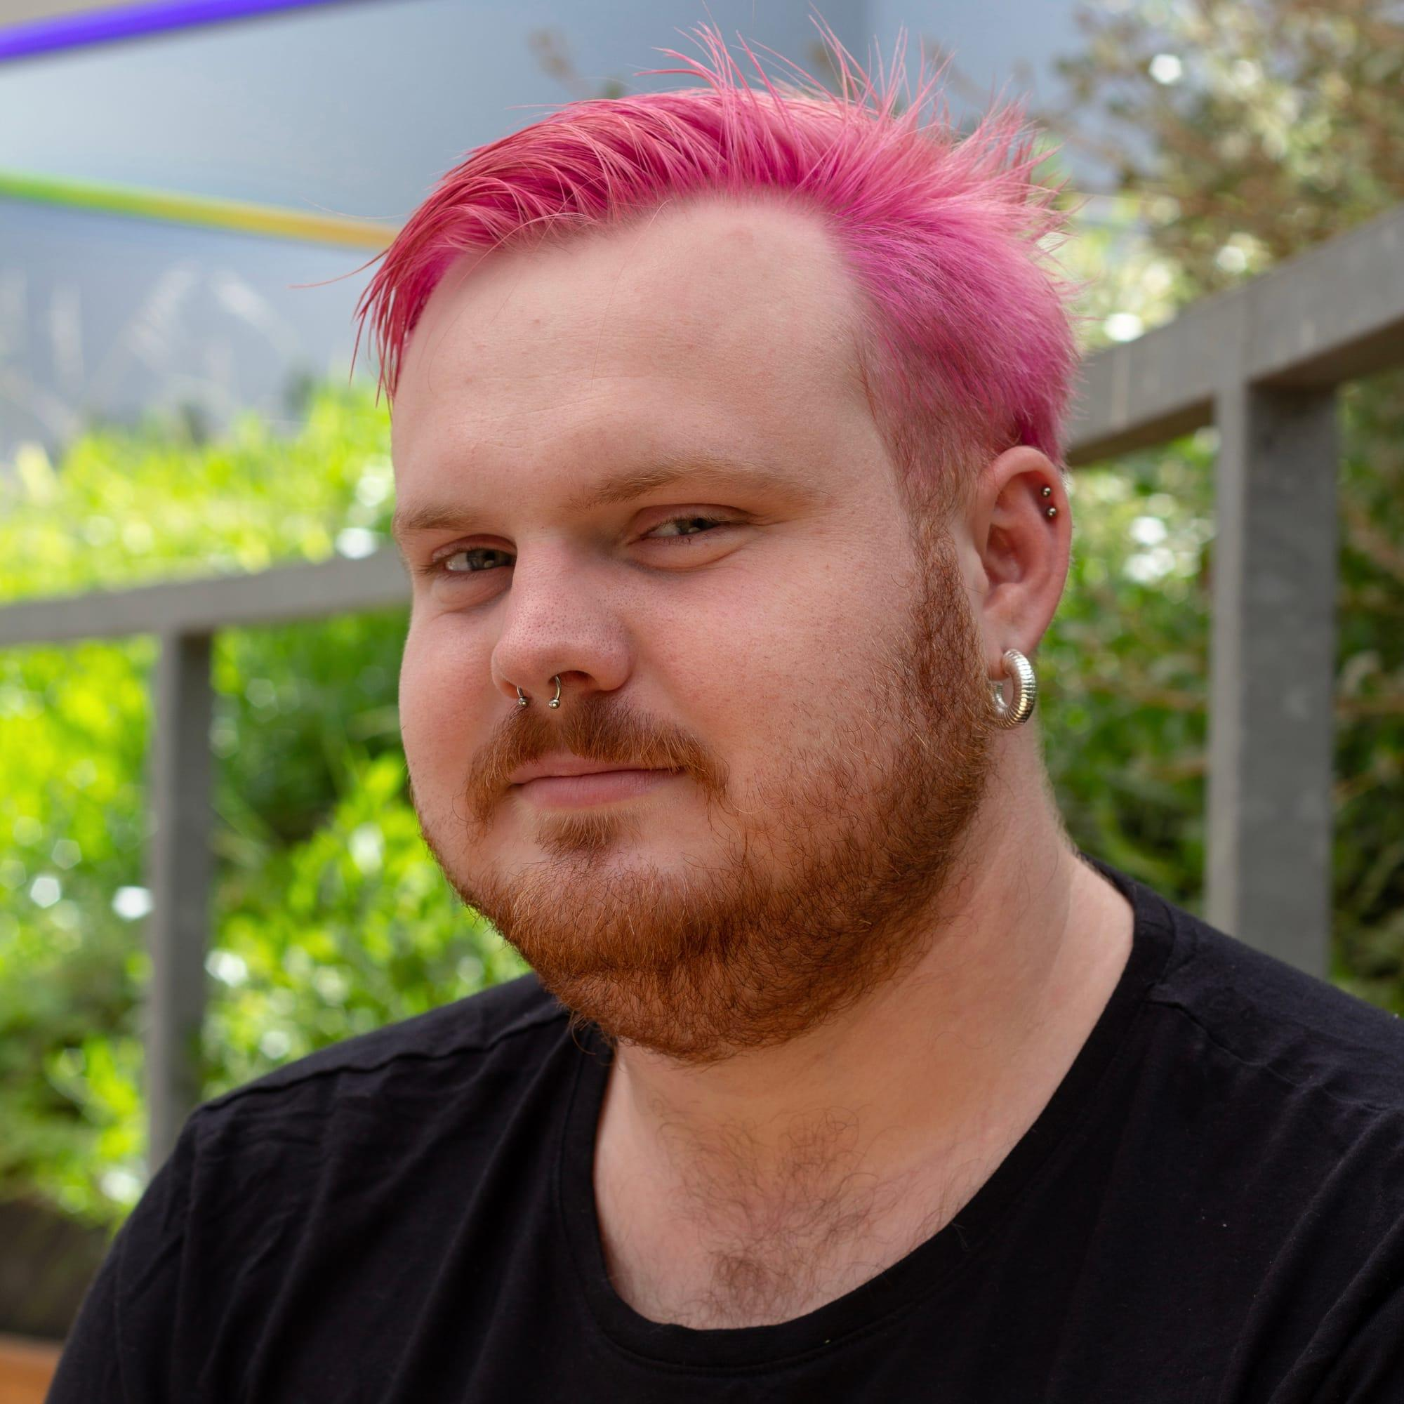

You can email them at ryan@ryanhamilton.work, and you may also see them at opening night on 8 September.

If you have any questions about the La Mama Hope Punk festival, or specific details about the venue, the best people to contact are the folks who work at La Mama theatre. You can email them at

Event details
Between training cycles and supply runs, Alex and Cam debate the values they can and cannot leave behind as their fight for survival intensifies. In an underground burrow, the two friends confront their proximity to danger, ill health, and their pursuit for mutually assured survival.

Written by Jamila Main (‘Benched’, ‘Pillow Talk’, ‘Butterfly Kicks’), ‘How to Eat Rabbit’ destroys the myth of individualism and unites a majority disabled creative team.

‘How to Eat Rabbit’ (Commendation, Griffin Theatre Award, 2021; Merit Award, State Theatre Company of South Australia, 2019) is a dark comedy for your existential crisis.

Cast & Crew
Producer: Pillow Fight Theatre
Playwright, Performer: Jamila Main
Director and Lighting Designer: Lilah Benetti
Performer: Nory
Sound Designer and Composer: Cynthia Spleen
Set and Prop Designer: Lara Chamas
Access and Marketing Coordinator: Ryan Hamilton
Assistant Stage Manager: Raffaella Phelan
Voice Artist and Captions Operator: Maxine Ellah
Access Support: Loom Arts and Management
Hero Image Photographer: Darren Gill

Content warnings
When watching How to Eat Rabbit, please be prepared to witness:
- Visceral discussion of hunting, preparing, and eating animals.
- References to climate change, apocalypse, and fascism.
- Brief discussion of menstruation using non-gendered language.
- Depiction of simulated pain.
- Infrequent coarse language.
- Fake blood.
- Simulated consumption of unprescribed medication

There are more detailed content warnings later in this guide, they contain spoilers for the show.

Ticketing
Standard: Select this ticket if you do not hold a concession card.

Concession: Select this ticket if you are a concession card holder. You may be required to provide your concession card when arriving at the venue.

Mob Tix: If you are Aboriginal or Torres Strait Islander you can select this ticket. You are not required to provide any proof you are Aboriginal or Torres Strait Islander.

Wheelchair Standard: Select this ticket if you will remain in your wheelchair to watch the show. You will be seated in the front row of the theatre.

Wheelchair Concession: Select this ticket if you will remain in your wheelchair to watch the show and are a concession card holder. You will be seated in the front row of the theatre.

Companion Cards: La Mama is a Companion Card affiliate. Companion Card holders qualify for concession price tickets and a second ticket at no cost for their companion. Please select the respective options when booking online, or contact La Mama office at info@lamama.com.au or 03 9347 6948 (call or National Relay Service available), or inform Front of House that you are companion card holder to book tickets.

Information about the venue of the show
La Mama Theatre is on traditional land of the Kulin Nation. We give our respect to the Elders of this country and to all Aboriginal and Torres Strait Islander people past, present and future. We acknowledge all events take place on stolen lands and that sovereignty was never ceded.

Carlton’s La Mama Courthouse (host of How to Eat Rabbit), is at 349 Drummond Street. It has been managed by La Mama since the mid-1990s, and is one of two theatres La Mama operates. La Mama Courthouse is a wheelchair accessible venue with step-free access (excluding the theatre seating bank).

The La Mama Courthouse is located at 349 Drummond Street, Carlton, behind Lygon Court and the Nova Cinemas, and close to Elgin Street.

How to get there
You can find the venue on Google Maps to plan your own way there.

Public Transport

Trams
1 & 6 Stop #112 Lygon St / Elgin St Walk east along Elgin St and turn right on to Drummond St, it will be on your right (4 mins)
1, 3/3a, 5, 6, 16, 64, 67, 72 Stop #1 Melbourne University / Swanston St Walk east along Faraday St and turn left on to Drummond St, it will be on your left (7 mins)

Buses
200, 207 Lygon St / Elgin St Walk east along Elgin St and turn right on to Drummond St, it will be on your right (2 mins)
250, 251 Elgin St / Rathdowne St Walk west along Elgin St and turn left on to Drummond St, it will be on your right (3 mins)

Train
Melbourne Central Station or Parkville, followed by a tram or bus ride above

Bike
If you ride a bike, you’ll find plenty of bicycle parking at the back of Lygon Court on Drummond Street, and also in the forecourt of little La Mama on 205 Faraday Street. The closest Melbourne Bike Share station is at Argyle Square on Lygon St, south of La Mama. Buy a helmet from the 7-Eleven on Lygon St along the way.

Driving
Finding parking near La Mama can be very difficult, especially on Friday and Saturday nights, so if you need to drive, make sure you allow plenty of time to find a park. In the area of the venue, parking inspectors regularly patrol the streets.

Here are some locations you may find to park in:
- There is free and metered parking on Drummond Street and surrounds.
- There is one accessible parking space immediately outside La Mama Courthouse on Drummond St.
- There is an underground car park at 333 Drummond Street, Cinema Nova Carpark, paid parking.
- There is a car park at Miller Lane, Elgin Street Public Parking, paid parking.
- There is an underground car park at 255 Drummond Street, Carlton Clocktower Carpark, paid parking. Please note there is a recent history of car’s veubg broken into, as there is no security and no CCTV.

Accessible Parking

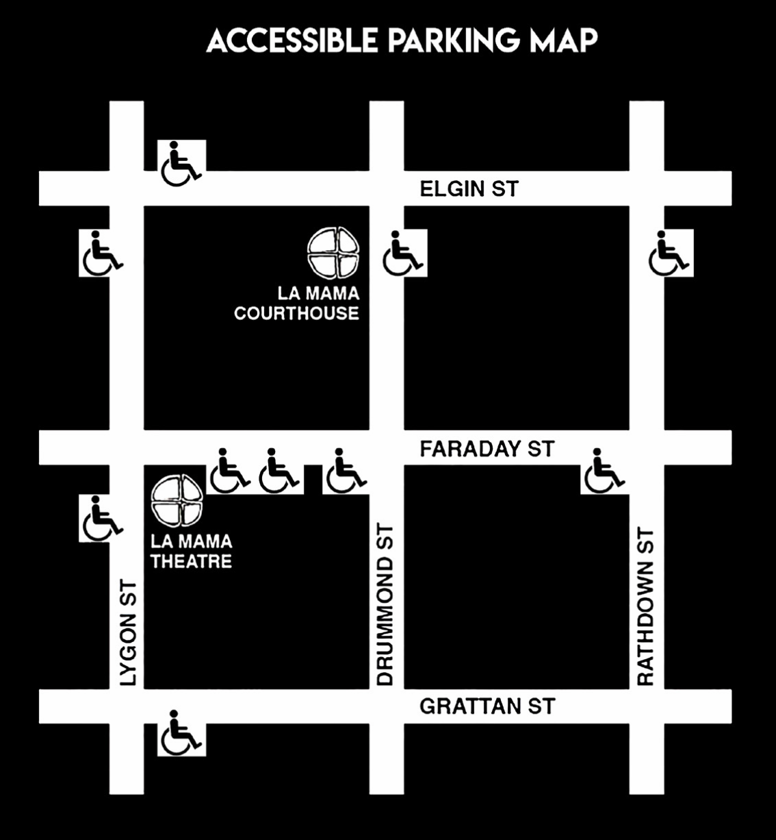

You can learn more about the accessibility of La Mama Theatre on their website.

Arriving at La Mama
La Mama Courthouse is accessed via a wrought iron gate at 349 Drummond Street, Carlton, Victoria, 3053, Wurundjeri land. The gate will be open when you arrive.

La Mama Courthouse’s front of house and bar is open one hour before the show starts. For How to Eat Rabbit this means that the venue is open from 6:30pm.

Once you enter through the gate, there is an outdoor foyer area with wooden bench seating. The ground is level, smooth asphalt.

There will be a front of house booth where you will confirm your tickets with La Mama front of house staff. They will also give you a free raffle ticket.

Please let the front of house staff know about any access requirements you need them to accommodate. For example, you can request a front row seat, you can be seated before the rest of the audience enter the theatre, or request any assistance with being seated.

There is a bar in the outdoor foyer. You can purchase drinks and snacks from the bar. There are alcoholic and non-alcoholic drink options.

There is also an indoor foyer area with various chairs and wooden floors. If you require assistance with being seated in the theatre, we recommend you wait in the indoor foyer.

Front of house staff will announce when you can enter the theatre and choose your seats.

Venue Accessibility
Theatre Door Width: 86cm

If you are a wheelchair user with a mobility device wider than 86cm, please get in touch before the show so we can try to meet your access requirements in the most comfortable way for you, by contacting Myf at myf@lamama.com.au or (03) 9347 6948.

Accessible bathroom: door is wooden and can be heavy/awkward to open/close while using a mobility aid. Grab bar on wall by toilet.

Unisex bathroom: door is wooden and heavy. All genders toilet.

Assistant Animals: Guide dogs and service animals are welcome at La Mama. Just let us know at the point of booking and when you arrive at the theatre. We have water bowls for service animals at both venues.

How you will be seated
Just before the show is due to start, the front of house team will announce that the show is about to start. They will give an acknowledgement of country, and announce that the doors to the space are opening.

They will likely do a raffle for a little prize either before you enter the theatre, or after everyone has sat down. When you check in, you get a little raffle ticket. If your number and colour is called, you should speak to the Front of House team to collect your prize.

When you walk in, you are able to sit wherever you like because the seating is general admission. Some people may prefer to sit in the front row, or near an aisle. Find a seat that is comfy for you.

The floor of the theatre is smooth masonite and is painted black. There will be soft lights illuminating the seating area. The seating bank can be accessed via steps.

The first row of seating is at stage level, first row designated for wheelchair users, raked seating accessed via steps. Seats are standard plastic chairs with back rests and are cushioned. You are able sit wherever you would like.
Once you take your seat, you might notice there’s some music playing before the show starts. This will end around the same time the lights go down for the show to start.

The dimensions of the theatre seats are: Width 490mm; Depth 530mm; Seat height 460mm.

If you are using a wheelchair or mobility aid, you’ll sit in the front of the theatre.

You can request the front of house team provide additional support to you to seat you. If you are attending the Auslan interpreted performance and require a seat in view of the Auslan interpreter, please let the front of house staff know so they can ensure you are seated in view.

Lock out policy
If you arrive late to the show, we cannot admit you into the theatre. You can leave the show at any time, but we sadly cannot re-admit you.

Other things around the venue
Here are some food venues and other essential shops you might need to visit while you’re in the area.
- Heart of Carlton, cafe, open 6am-6pm weekdays and Saturdays, (everything is $4)
- Sun hands, cafe, open 8am-3pm Sundays-Thursdays, 8am-10pm Fridays-Saturdays
- Woodfrog Bakery, open 8am-5:30pm everyday
- Taquito, restaurant, open noon-10:30pm Mondays-Wednesdays, noon-11pm Thursdays, noon-12:30am Fridays-Saturdays
- Gemma Simply Italian, 5pm-10pm everyday except Tuesdays
- Plenty of restaurants, bars
- Woolworths Carlton, open 7am-11pm everyday, 333 Drummond St Carlton
- Gertrude Grocer Carlton, open 8am-8pm everyday
- Pickford Pharmacy, 177 Elgin St, open 9am-5:30pm
- Cinema Nova
- Clothing stores

Information about the show
The below content warnings include spoilers for the show.

Depiction of Disability and Chronic Illness
The character Cam has an undiagnosed disability/chronic illness. Their condition deteriorates throughout the play. Cam is portrayed by a disabled actor.

The depiction of disability and chronic illness in this play may be triggering or upsetting, but may also be validating and familiar. Audiences who may struggle to watch a disabled person simulate pain and distress are encouraged to read this guide and consider whether they can safely watch the play.

There are moments throughout the play where Cam experiences sudden, unexplained pain in their pelvis and abdomen.

At times Cam struggles to walk, stand, and is unable to climb the ladder to exit the burrow.

Cam conceals their pain and symptoms from Alex.

Cam secretly takes pain medication from a pill bottle. In one scene, the medication has run out
and the pill bottle is empty.

Cam flicks through YouTube videos searching for an answer to their condition. The videos we hear reflect gym bro’s urging people to push through pain, a health influencer dismissing symptoms, and an undiagnosed person sharing their lack of medical support. We only hear a line or two from each video.

The characters discuss access to hospitals declining and becoming more expensive. They briefly wonder if they’ll have to find doctors and nurses doing illegal consults to get Cam medical care.

Cam mentions having an contraceptive, and expresses concern about it expiring and needing to be removed. Cam and Alex discuss the lack of pathways to getting it removed.

Alex implies they’ll have to remove the contraceptive themselves with their knife.

Alex mentions a friend whose contraceptive migrated and got embedded in an artery, but their friend had it safely removed and is okay now.

The play’s finale is dramatic, bold, and graphic. Fake blood is used. Cam’s symptoms reach a climax and their life is endangered. Cam is hemorrhaging blood from their vagina. Alex tries to care for Cam and to help them leave the burrow to get medical help. Alex calls the emergency number but a pre-recorded message and hold music plays. No one ever answers Alex’s call. Cam is too unwell to climb the ladder to leave the burrow.

Cam and Alex stop performing the emergency scene and drop character, the actor’s telling the audience that they will not perform a disabled character dying.

Discussion of hunting, preparing and eating animals
During Scene 1, the characters discuss methods of hunting animals, including using a snare and imagining an animal caught in the snare fighting for its life.
During Scene 1, Cam and Alex describe in detail how to prepare an animal for eating, including how to skin it. Cam describes the sensations of physically eating an animal when they don’t want to eat meat. Cam describes animal meat as meat, flesh, and a corpse.
There are repeated references to eating meat from hunted animals throughout the play, with Cam maintaining that they will not eat animal flesh.

References to climate change, apocalypse, fascism, and social collapse
Throughout the play the characters refer to climate change and climate catastrophes, including bushfires, floods, and poor air quality.
The characters refer to the world ending, apocalypses, and the world deteriorating. In Scene 6 there is a black out which Cam mistakes as the world ending and panics, but Alex quickly reassures Cam that it’s not the end of the world.
The characters discuss the hospitals charging more for healthcare, people shoplifting supplies, trading goods, and refer to going to get supplies as “supply runs”. There is a general sense that the above ground world is getting less safe, which the playwright has drawn on from real current and recent events in Australia and globally.
The characters refer to “fascist fuckers”.

Sequences depicting severe, undiagnosed pain and distress
The actor playing Cam performs episodes of severe, undiagnosed pain which distresses them.

Sequence depicting a medical emergency
In Scene 11 Cam experiences a medical emergency where they are hemorrhaging blood from their vagina and are experiencing intense pain.
Alex calls the emergency helpline but the operator doesn’t pick up. Hold music and a pre-recorded message from the operator plays repeatedly.
This scene may be distressing, but Cam does not die, and the actors stop the scene. The actors address each other by their real names and talk directly to the audience. The audience is not expected to reply when the actors talk to them.

Alcohol
There is a bottle of alcohol onstage in Scene 10 and Scene 11.
Alex brings home a bottle of alcoholic spirits. Cam and Alex both sip from the bottle. The bottle is opaque and the audience doesn't see the liquid. Alex compares nonalcoholic drinks with alcoholic drinks and what they need to drink to cope.

Vomiting: Emetophobia Warning
Cam retches after unintentionally eating meat. Cam does not vomit, but heaves and makes noises. This may be triggering for people with Emetophobia.
Alex gags after burying a rabbit.

Fake Blood
During Scene 11, fake blood is used to simulate Cam haemorrhaging blood from their vagina.
The fake blood is made from corn syrup, red food dye, cocoa powder, and dishwashing liquid and is safe for humans.

References to Death and Dying
There are references to death and dying for both humans and animals throughout the play.
In the Epilogue, Cam exits the play via an off-stage elevator. This may be interpreted as Cam dying.

References to Menstruation Using Nongendered Language
Cam refers to their period using nongendered language.

References to Pregnancy and Children
Cam repeatedly states that they won’t touch human shit in reference to children.
Alex and Cam discuss not wanting to have children during the end of the world.

Infrequent Coarse Language
There are infrequent moments throughout the play that the characters swear.
“Fuck” is said, including variations such as “fucked up”, “fucking”, and “fuckssake”.
“Shit” is said infrequently as a cuss word. The characters also refer to human faeces as “shit”.

Information about the performers and characters

Visual Descriptions of the performers

Cam


Cam is portrayed by Jamila Main in this production. Jamila is a white femme person in their early thirties. Jamila has light brown hair in a bob cut. Cam’s costume is a beige jumper, light brown cosy trousers, and white socks. For Scene 11, Cam wears grey shorts that are stained with dark red fake blood.

Alex

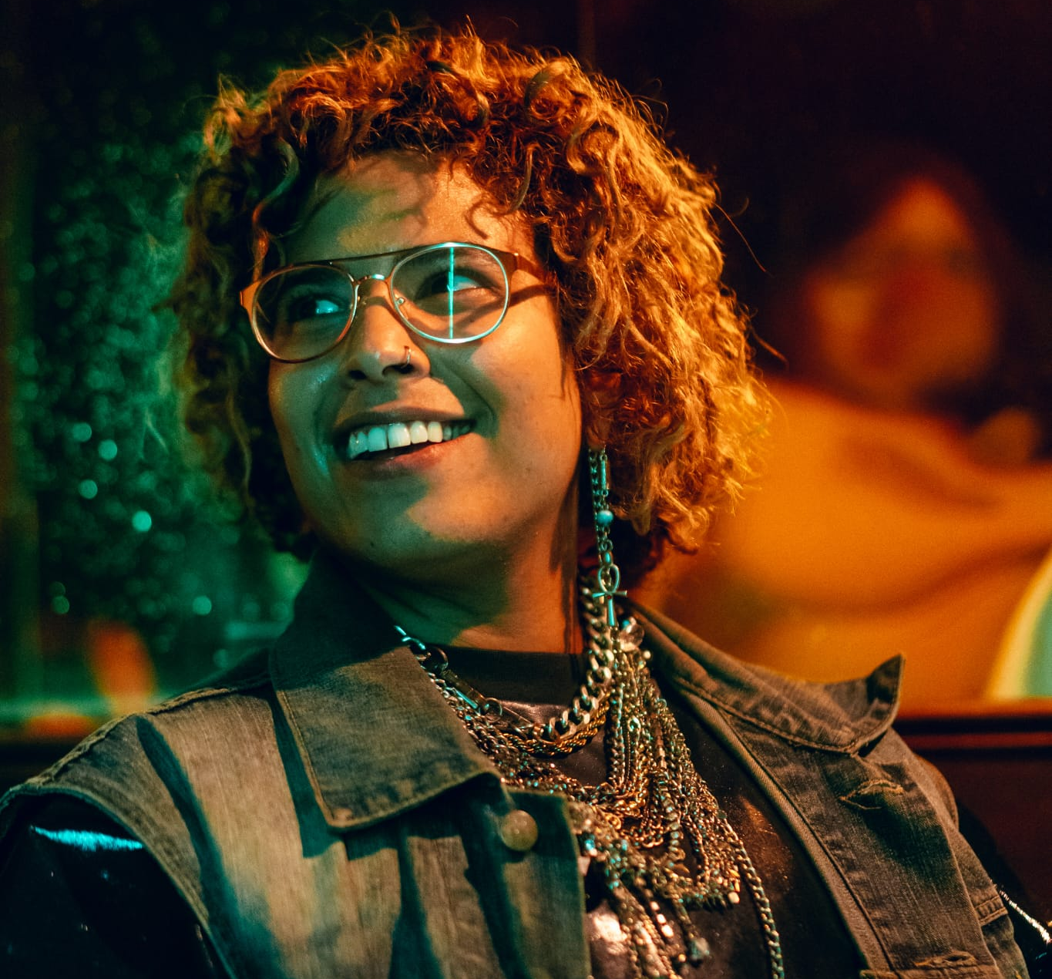
Alex is portrayed by Nory in this production. Nory is an Egyptian woman in her mid thirties. She has curly dark brown hair with some coppery/blonde highlights. Nory has a silver nose ring. Alex’s costume is a dark green hiking jacket, the pattern mimics foliage. Alex also wears black leather shorts and black leather boots.

Pictures and info about the space the show is performed in
To come

Support resources

Support Act
A free phone counselling service for anyone working in Australian music and arts. You do not have to be in crisis to call the helpline.
Call 1800 959 500

Lifeline Australia
A 24 hour crisis support service.
Call 13 11 14 or visit their website

Thorne Harbour Health
Thorne Harbour Health has free and low cost counselling programs for queer and trans people. (03) 9865 6700 / https://www.thorneharbour.org/services/mental-health

Additional resources
Beyond Blue: 13002246365
QLife: 1800184527
Rainbow Door: Call: 1800 729 367, SMS: 0480 017 246
Mind Australia-Aftercare: 1300 286 463
Suicide Callback Service: 130065946
MEAA Wellbeing Committee, @meaawellbeingau on Instagram, has a link tree with various resources and support services to support your mental health. The Wellbeing Committee also has recommendations for counsellors who specialise in working with people in the performing arts.

